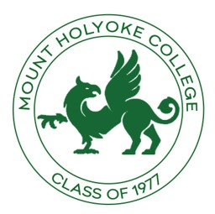

MHC
Class of 1977

October 2020
Survey

Survey Overview

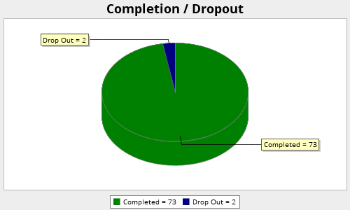

Sent to 409 classmates

Viewed  100 | Started  75 | Completed  73 | Completion Rate  97.33% | Drop Outs (After Starting)  2 | Average Time to Complete Survey  2 minutes

Q1. How did you hear about the class meeting on Friday, October 2, 2020?

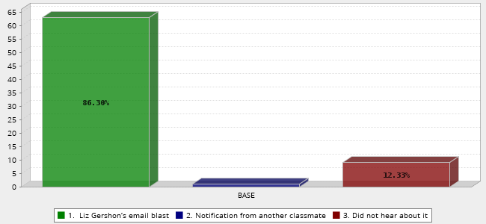
 | Answer | Count | Percent
1. | Liz Gershon’s email blast | 63 | 86.30%
2. | Notification from another classmate | 1 | 1.37%
3. | Did not hear about it | 9 | 12.33%
 | Total | 73 | 100%
Q2. Did you attend October 2 call?
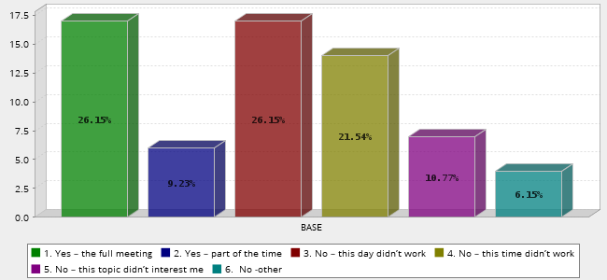
 |  |  | Answer | Count |  | Percent
1. |  |  | Yes – the full meeting | 17 |  | 26.15%
2. |  |  | Yes – part of the time | 6 |  | 9.23%
3. |  |  | No – this day didn’t work | 17 |  | 26.15%
4. |  |  | No – this time didn’t work | 14 |  | 21.54%
5. |  |  | No – this topic didn’t interest me | 7 |  | 10.77%
6. |  |  | No -other | 4 |  | 6.15%
 |  |  | Total | 65 |  | 100%
 | 10/12/2020 | Life is busy and my connection to Mount Holyoke has been challenged by vitriolic politics
Q3. What were your impressions of the meeting?
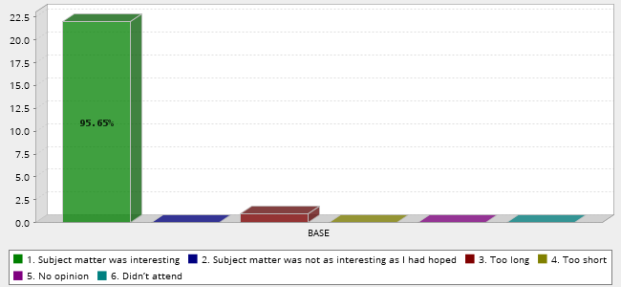
 | Answer | Count | Percent
1. | Subject matter was interesting | 22 | 95.65%
2. | Subject matter was not as interesting as I had hoped | 0 | 0.00%
3. | Too long | 1 | 4.35%
4. | Too short | 0 | 0.00%
5. | No opinion | 0 | 0.00%
6. | Didn’t attend | 0 | 0.00%
 | Total | 23 | 100%
Q4. Did you have any technical issues connecting on Friday?
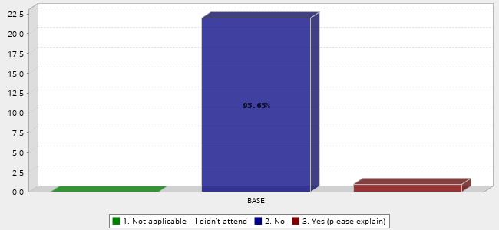
 | Answer | Count | Percent
1. | Not applicable – I didn’t attend | 0 | 0.00%
2. | No | 22 | 95.65%
3. | Yes (please explain) | 1 | 4.35%
 | Total | 23 | 100%

Comments
10/12/2020 A bit tricky joining from my iPhone, just due to small screen size!
Q5. How often do you participate in virtual events?

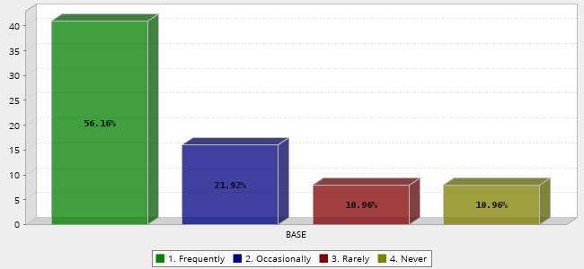
 | Answer | Count | Percent
1. | Frequently | 41 | 56.16%
2. | Occasionally | 16 | 21.92%
3. | Rarely | 8 | 10.96%
4. | Never | 8 | 10.96%
 | Total | 73 | 100%
Q6. What areas are of interest to you for future meetings? Check all that apply.
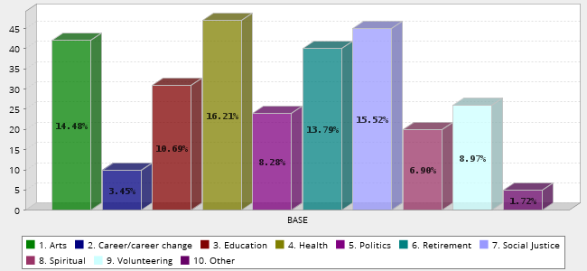
 | Answer | Count | Percent
1. | Arts | 42 | 14.48%
2. | Career/career change | 10 | 3.45%
3. | Education | 31 | 10.69%
4. | Health | 47 | 16.21%
5. | Politics | 24 | 8.28%
6. | Retirement | 40 | 13.79%
7. | Social Justice | 45 | 15.52%
8. | Spiritual | 20 | 6.90%
9. | Volunteering | 26 | 8.97%
10. | Other | 5 | 1.72%
 | Total | 290 | 100%

“Other” Comments
10/13/2020 none
10/12/2020 Climate action
10/08/2020 Sciences
10/07/2020 Finance
Q7. Are you interested in presenting to the class?

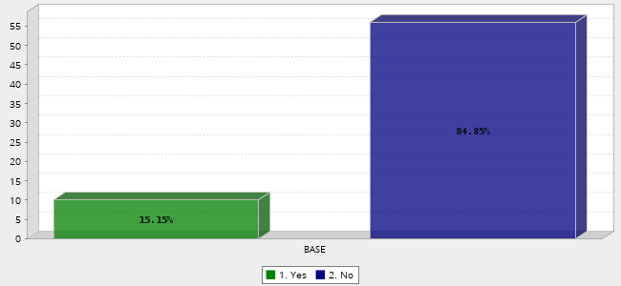
COMMENTS

- Jodie Hurwitz- glad to answer questions about heart rhythm problems; not much use with anything else
- Using humor as an engaging way to open ‘difficult’ conversations.
- I already presented 8-16-20 and Liz and I are planning a follow- up closer to the holidays! Practicing Conscious Self-Care through Life's Big Changes Deborah Roth
- I presented at Liz Gershon's meeting.
- Have already done one regarding COVID- alway available for updates
- We run a small charity in rural Cornwall england. We collect aid for refugees in France and Greece and fund 2 education programs for post genocide Yazidis in Iraq. Our area is poor but the people are generous. Dispite what our governments say, most people are keen to help those with less. Please note I am 5 hours ahead of EST. Shelley Meister
- Arts - I am a professional oil painter: pennybillings.com
- Diversity, equity and inclusion topics. Using listening circles in organizations for more impactful meetings. Maura Fallon
- Crafts :)
- Would be willing to be in a panel discussion about volunteering in retirement or traveling abroad . ( I could see a series about different places to visit and share insights and do not miss items. I did New Zealand South Island for a almost 4 weeks in 2019.) Alex Woody

Names: Woody, Meehan, Fallon, Fillios, Meister, Echterling, Prien, Stone, Mendler, Hurwitz
Q9. What is your preferred way(s) to hear from class officers about upcoming events? (click all applicable)

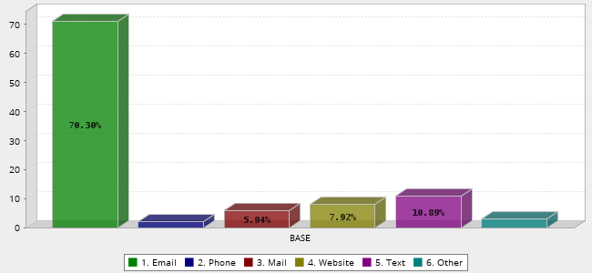
 | Answer | Count | Percent
1. | Email | 71 | 70.30%
2. | Phone | 2 | 1.98%
3. | Mail | 6 | 5.94%
4. | Website | 8 | 7.92%
5. | Text | 11 | 10.89%
6. | Other | 3 | 2.97%
 | Total | 101 | 100%

Other Comments

10/12/2020 Class of '77 facebook page
10/07/2020 FaceBook
10/07/2020 Class Facebook Page

Q10. Our 45th reunion is not that far away (Spring 2022)! Are we likely to see you?

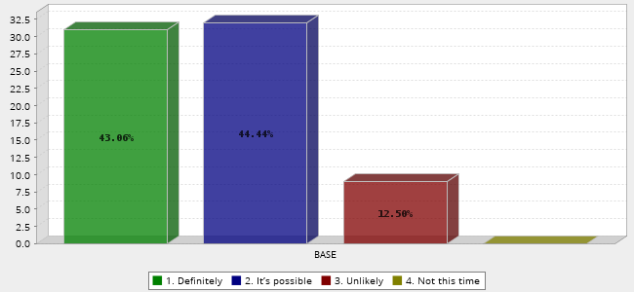
 | Answer | Count | Percent
1. | Definitely | 31 | 43.06%
2. | It’s possible | 32 | 44.44%
3. | Unlikely | 9 | 12.50%
4. | Not this time | 0 | 0.00%
 | Total | 72 | 100%
Q11. Have you checked to make sure your profile on the Alumnae Association website (directory.alumnae.mtholyoke.edu) is up to date?
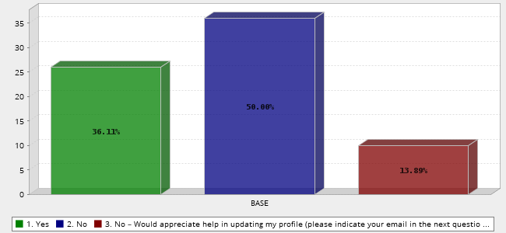
 | Answer | Count | Percent
1. | Yes | 26 | 36.11%
2. | No | 36 | 50.00%
3. | No – Would appreciate help in updating my profile (please indicate your email in the next question and we will reach out to you) | 10 | 13.89%
 | Total | 72 | 100%
People who wanted help with Updating Contact people
- drfranadler@gmail.com
- mariapia.genovese@fastwebnet.it
- olh1961@gmail.com
- hmitchmd@gmail.com
- jennifer.a.cox1@gmail.com
- kprien@alumnae.mtholyoke.edu
- missnickys@missnickys.com
- janotmendlerf98@alumni.tufts.edu
- catherinekligler@comcast.net
- lesliesj@valdosta.edu
Q12. Do you have any other comments or suggestions?
- I would encourage all MHC students and alumnae to look at MHC as our 'roots' and to re-read our alumnae quarterlies and go onto the internet entries on MHC to 're-charge' and 're-energize.' MHC is a beautiful, good and wonderful college for women which treasures us as women, and which we should treasure in turn. We will be able to give more to the world by going back to our MHC roots and remembering the extraordinary privileges we enjoyed as students. We will thus be able to give more to the world, our friends, our dear families and our loved ones. MHC teaches us to love and give and instils a permanent desire to excel and make the world a better place for all, especially for women. MHC is a place from which we may permanently draw strength to succeed.' Take care and Stay Safe! Elizabeth Rerente Brown '77
- nope
- I presented at one which is why I said no to that question. I try to attend each one and I appreciate the effort Liz makes.
- I think that these are great - and I would present if I thought I had something worth presenting1
- Catherinekligler@comcast.net
- I’m sorry that I don’t like virtual events or zoom calls. So, most likely, I am out for anything of that nature during these Days of Covid.
- Plz share survey results w/class elist!
- Thanks for doing this!
- Thaw latest Zoom get-together was excellent! Thanks to all who organized and presented!
- Thanks for making this survey! Well done.. Janet
- Photos are really great for getting me engaged with communications!
- i DO appreciate this initiative, and would have participated in the ZOOM, but we're up here visiting with a 5=month-old grandchild we weren't able to see in person for the first 4 1/2 months, and it's been hard (i.e. impossible) to focus on anything other than that small person! Once we get back to Nashville/real life/boring Covid seclusion there's a much better chance i'll remember to chime in.
- None now.
- The program was excellent, very interesting. I think each speaker could have had their own session though,. It was just too much info for one program and I had to leave at 8 (before the wrap-up) because I had to fix dinner. All three speakers were great and Liz did a great job hosting the meeting - thanks to all for your efforts!
- I'm really enjoying the class zooms and I appreciate your efforts to put them together! Thank you!
- This was a great survey, thank you for doing it Alex. Not sure if you want to include my responses or not, they are skewed....Liz Gershon P.S. Was this survey anonymous?
- 10/07/2020 Great initiative. Keep up the good work. Also, just FYI, this email went into my spam.
- Not scheduling the zoom meetings on weekends
- I'm greatly enjoying the class zoom meetings. I think 5-6 times per year is a good number of these programs to have.
- Thanks to all of you for your efforts to build community at this time. Even if my ability to participate is limited, I take real pleasure in knowing that the Class is engaged in such substantive ways.
- So impressed with all your hard work. MHC '77 and the Communications Committee are so lucky to have you! Thanks.
- Only that I am less involved than I might be due to the time difference. Of course I understand that it is not possible to be convenient for everyone.
- Thank you for your efforts to keep our classmates connected. Very much appreciated.
- Surprised I was not contacted for the most recent presentation on the arts, since I was included in a profile in the Alum Quarterly a few years ago, and I did not even hear about it.
- Not now. To be frank, I continue to work full time, so I haven't had time to think MHC meetings. I will pay more attention in the future. Thanks!
- Thanks Alex and Susan. Great survey
- I meant to do the 2 October program. I just didn't get to.Sorry I missed it because the topic really appealed to me. I appreciate the efforts. A plain Zooom get-together might also be nice.
- I appreciate the efforts. Our class has historically been uninvolved it has always seemed to me. I wonder if it was the time in history that we attended college?
- Need to update profile info. Email: okh1961@gmail.com.

