Profile of Laurie Fendrich, Class of 1970

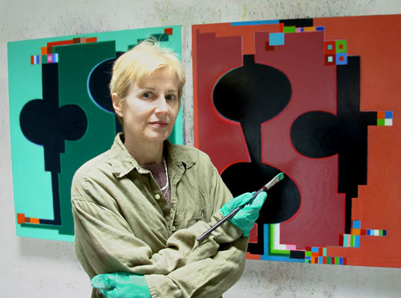

One of our recent Alumnae Achievement Award recipients, Laurie was a political science major at MHC who took classes in the art department as well. Her passion for policy and thoughtful analysis lives today in her writing for the Chronicle of Higher Education. In January next year, she will be on a panel at UC Davis discussing the values of art and how artists today fit into society with the pressure for careers in Science, Technology, Engineering and Math. Her recent essay on how critical thinking has sideswiped the world of art is just one example of her deep evaluation of how liberal arts and analytical methods can intersect and find meaning in each other.
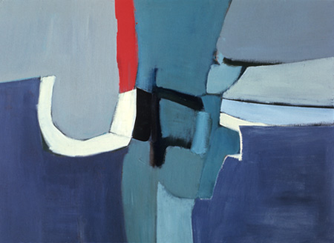
Spring 1971
As a 2016 recipient of a Guggenheim Fellowship in Fine Arts, as well as a recipient of an earlier National Endowment for the Arts award, Laurie is an accomplished painter, nurtured by her few classes at MHC. Her love of drawing began during her early years when she was bedridden with rheumatic fever at 12. When her diagnosis finally arrived, she became the center of her family’s attention, and a year later she was a new person.
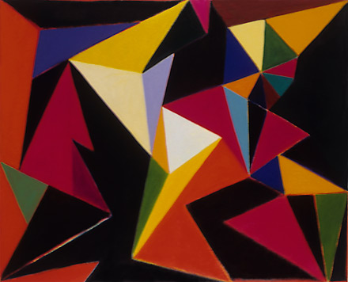
Nature’s Privilege 1988
Following an MFA from the Art Institute of Chicago, she began to paint in a serious way, which continues to the present. A retrospective in 2010 at the Scripps Campus art gallery has blossomed into a solo show that runs through December 3rd at the Los Angeles gallery of Louis Stern Fine Arts (http://www.louissternfinearts.com/laurie-fendrich-3). Here we see an accumulation of influences that over the years have evolved into a modern synthesis of bold color, geometric form, constructivist landscapes and what might be called a metronome between modernist and baroque influences.
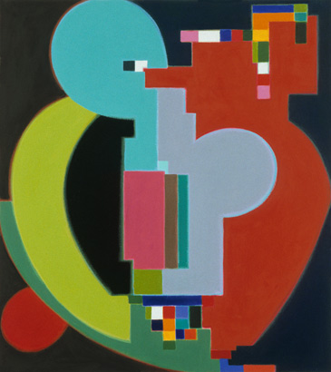
Zoot, 2002
“I fret over details,” Laurie confesses. She finds that the heart of her painting is a slow buildup of layers. Often a preliminary sketch can give rise to traces of underpainting where sturdy and solid forms embrace as they emerge on the canvas. Conscious of her art historical studies, she knows the Russian Constructivist movement, the grids of Cubism, the playful use of light by the Impressionists, and the boogie- woogie of the Bauhaus tradition. All of these thoughts weave a product that is tight, sophisticated and a harmony of eternal and universal truths.
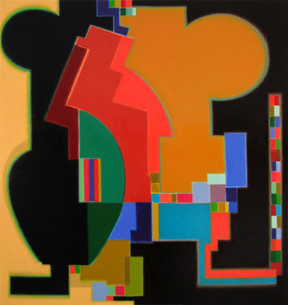
Picture in the Hall 2008
New York Times art critic Grace Glueck said her work has “decorous pizzazz.” An artist she admires, Wayne Thiebaud, noted that painting is like baseball - you have to accept the game as a whole entity. Laurie and her husband Peter Plagens, who is an art critic for the Wall Street Journal, have maintained a bi-coastal presence in their lives with art access in both camps. Laurie taught painting for 25 years at Hofstra University on Long Island and brought critical discipline to her work with students on the fundamentals of the color wheel and artistic composition. Like her favorite author, Jane Austen, Laurie often exhibits a dry wit which ricochets around her life and work like a rolling ball on a pool table.
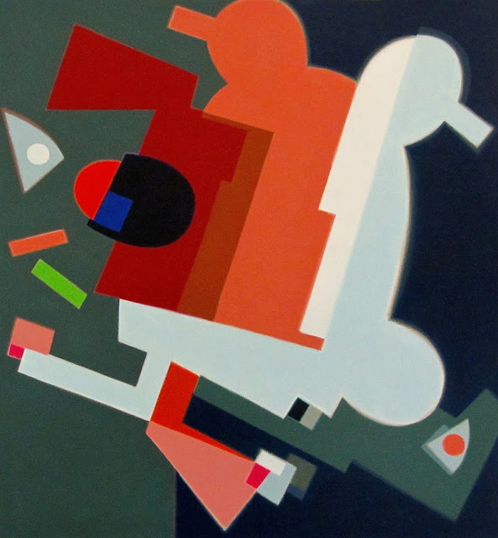
Loose Talk 2014
Laurie and I had the amazing coincidence to find we were born in the small hospital in Paterson, New Jersey five weeks apart in 1948. Our lives in political science and art weave the right and left brain tendencies into one fascinating mix. What fun for me to find a soul sister right under my nose in my MHC Class of 1970!

Want to read more about Laurie? Click on this link for an article in Artillery Magazine: http://artillerymag.com/33641-2/

--Sharon Murray Lorenzo

March 30, 2016, Two Coats of Paint, How Critical Thinking Sabotages Painting.
Julie Karabenick, An Interview with Artist Laurie Fendrich, April 2007, Geoform.

