Profile of Stephanie Williston, Class of 1970

Stephanie Williston is another very accomplished member of the Class of 1970. After getting her BA in Biology from MHC and an MS in Wildlife Biology from the University of Massachusetts, she joined the Peace Corps in 1973, serving two years in Kenya as a high school biology teacher.

Upon her return to the United States, Stephanie pursued a lifelong interest, receiving a degree in Counseling in 1978. A year later, she married Thomas Donovan and moved to Manchester, New Hampshire, where Tom began his career as a lawyer and Stephanie went into private practice as a Licensed Marriage and Family Therapist. While raising their children, Kate and Patrick, she went back to school, completing her Ph.D. in Clinical Psychology at age 52.

After a 35-year career as a therapist, teacher, and researcher, Stephanie agreed with Tom that it was time for both of them to shake things up. In September, 2012, they left for 26 months of Peace Corps service in Botswana, where they worked in local secondary schools educating students and staff on HIV prevention and healthy living.

While Tom is now with the Attorney General’s office in Concord, New Hampshire, Stephanie is enjoying some free time at last and working her way through the history of art -- ever the self-educated woman!! As she said in her reunion essay, “Learning never ends, and you are never too old to do something new and enriching.”

Splitting her time between New Hampshire and her second home on Great Diamond Island off the coast of Maine, Stephanie says she goes to bed each night so grateful for clean sheets and a hot shower. She remembers the days of taking bucket baths and washing her clothes in a tub in Botswana, not knowing if (or how much) water would be running. After over two years with no car, no TV, no restaurants, no family or old friends nearby, she is delighted to have served her country once again and made her Alma Mater proud!!

Sharon Murray Lorenzo

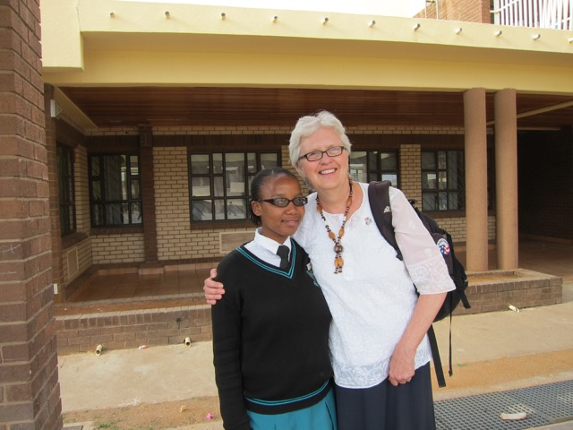
Stephanie with a student from Goodhope Senior Secondary School
in Botswana

