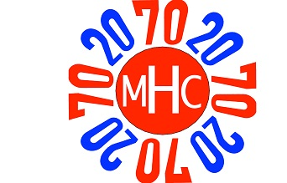

July 2016
Dear Members of the Class of 2020,
In the late summer of 1966 we were preparing to leave home and begin our journey into the future within the Mount Holyoke College community. As your fifty-year connection class, may we be the first to say, “Welcome!”

Congratulations on your admission and planned attendance at our exceptional college. We are certain that the next four years will be filled with life-changing experiences, will advance your remarkable potential and will launch your purpose and place in the future.

We wish you the very best as you begin your academic journey, make enduring friends, participate in memorable traditions and take full advantage of the many wonderful opportunities Mount Holyoke’s unique liberal arts education offers. You will build networks -- not just between now and May 2020 -- but you will also embark on a life-long journey nurturing relationships and links with the entire MHC alumnae body (over 37,000 strong.)

In May of 2020 many members of the Class of 1970 will return to South Hadley to honor our shared education, joyously celebrate your graduation and inclusion in the Alumnae Association and enjoy our Fiftieth Reunion. Along the way we will be there for you to provide support, answer any questions you may have and cheer you on during your four years in South Hadley. Our classes share a special bond now and will continue building it for many years to come.

Our connection will begin when you gather in the Pioneer Valley this fall. We will be on campus to welcome you during orientation and hope that you enjoy meeting some of our classmates then. Later in the fall, you will elect your first set of class officers. Thereafter, together, we will plan ways that our two classes can interact over the next four years.

We wish you well as you prepare for your arrival in South Hadley at our beloved alma mater, Mount Holyoke College.

With warm regards,

Ann Richardson Berkey Susan Swart Rice
Vice President, ‘70 President, ‘70
Connections Class Committee Chair

P.S. To learn more about our class, please feel free to visit our website: (http://sites.alumnae.mtholyoke.edu/wp/1970/)

