Profile of Jean Olson, Mount Holyoke Class of 1970

Jean was an undergraduate pre-med with a biological sciences major at MHC and took advantage of a major gift to the College in 1969 of an electron microscope. With this expertise she went on for four years of medical school at the University of Rochester followed by four years of residency at Johns Hopkins and post-doctoral study at Brigham and Women’s Hospital in Massachusetts. Her specialty in renal pathology has led her down many professional paths. The list of research projects and articles she has published is admirable and extensive. Most intriguing to me was her work with HIV-positive patients whom she discovered could tolerate a kidney transplant in many cases. To enliven her lectures at the University of California in San Francisco where she taught for many years she used photos and songs to keep her class engaged. Her second-year students did a You Tube video which is attached and even invited Jean to participate in the lyrics and choreography!
www.youtube.com/watch?v=FYekviedhAM
As of June 2015, Jean closed the books on this chapter of her life and has taken a new path for enlightenment and creativity. She is an active and engaged docent at the California Academy of Science where she will be trained soon on many aspects of the meteorites in their collection. She is also an elder in the Presbyterian Church and is a member of a national committee which writes the ordination exams for ministers. When she is not engaged in either of these things she is knitting and enjoying fantasy sports on ESPN! A planned move back to Massachusetts is imminent, where she plans to reengage with family and similar organizations in the Boston area.

Jean is another MHC graduate from our class who has embraced a full life of gifts and giving from her MHC education and experiences. Her stamina and contributions stand tall for us all to admire and emulate.

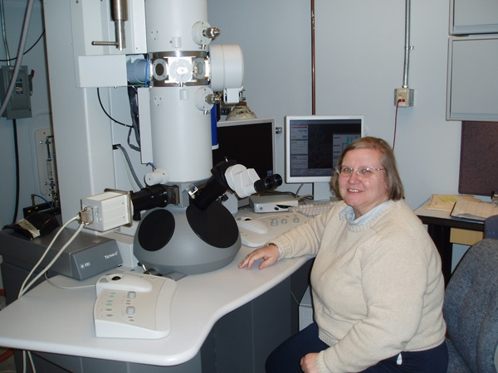

Sharon Murray Lorenzo

