Profile of Ann Richardson Berkey Class of 1970, Mount Holyoke College

Ann wrote a few words of advice for her classmates in our 45th reunion book, having lost her husband of 35 years to leukemia from Agent Orange exposure in Vietnam and their beloved dog three months later:

“Life will throw you lots of curve balls -- your ability to survive and indeed thrive will depend largely on how you pick yourself up, reach out to others and keep going in the face of failure, regrets, loss or hardship. Your happiness will not be measured as much by what you achieve as by how you achieve it. Pull other women up with you. Friends will always be an important tether to life, to reality, to joy -- take the time to stay connected.”

Ann’s words and accomplishments ring true for the uncommon woman: starting with her degree in French from Mount Holyoke, she rose to Senior Vice President of Public Affairs for the healthcare giant, McKesson Corporation. Ann is now continuing in the field with a strategic consulting firm of her own, advising companies and women business leaders in influencing government policy. As a member of the Gold Star Wives program for widows of veterans as well as vice chair of the board of the National Marrow Donor Program, she continues to play a vital role in encouraging participation on the Be The Match registry for worldwide bone marrow donations.

Ann is engaged with her family, keeping in touch with her children and a granddaughter, who live in Ann Arbor and San Francisco. She is actively involved in swimming, tennis and hiking, and enjoys time in her garden and hobbies. She has found that her Mount Holyoke years gave her the skill set she has needed for these vital years, where as an educated woman, she can make a difference in many spheres of life. Ann is a brilliant model for us all to emulate in our years ahead.

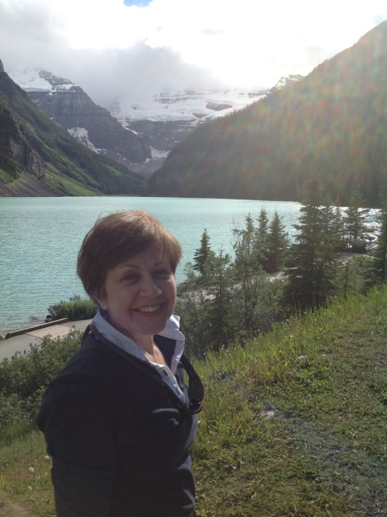

Sharon Murray Lorenzo