Profile of Judith Harris Rawson, Class of 1970

Those of us who went to College with Judy will always remember her leadership skills that shone on campus, in our capitol, and in her life beyond. As a political science major, she negotiated with unhappy students and their faculty leaders on campus during our days of radical unrest. After her internship in Washington for Senator Birch Bayh from Indiana, she continued to work for him and drafted the Senate version of the bill creating Title IX legislation which opened up many educational and later sports opportunities for women. She then married Bob Rawson and moved to Cleveland to enter Case Western Reserve Law School. Following three years with the law firm, Kelley, McCann and Livingstone, she began her local political career as an attorney for the city of Cleveland.
Judy served on both the Shaker Heights Planning Commission and its City Council, until she was elected Mayor in 2000. Serving in this capacity until 2007, she has now retired to a life devoted to both family and her favorite hobby of photography. Many of her important works can be seen on her website: Judyrawsonphotography.com
As the mother of two boys, Alex and Greg, she is also the delighted grandmother of four lovely girls. She and Bob keep an active pace with them in both Denver and Seattle. We remember Judy dancing and singing as the lead in our Junior Show, and we know she keeps up that effervescent personality on all fronts. “We Can Change the World” was not only a song lyric for her, but a motto she has emulated throughout her post-graduate life. She has served Mount Holyoke College as both a trustee and recipient of the alumna Medal of Honor for her dedicated legacy of leadership. Mary Lyon would be so proud of Judy and all she has accomplished in her lifetime, no doubt!

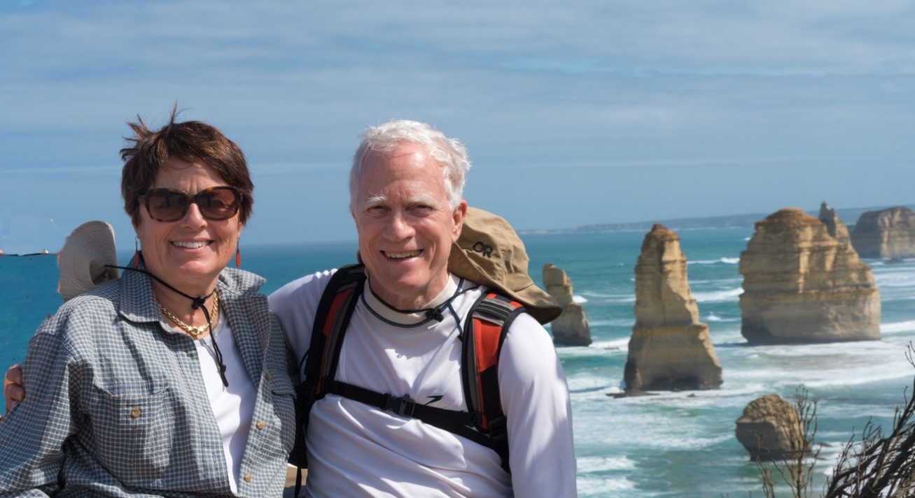

- Sharon Murray Lorenzo

