Kelleher awarded for contributions to nongovernmental nuclear policy community
March 22, 2017
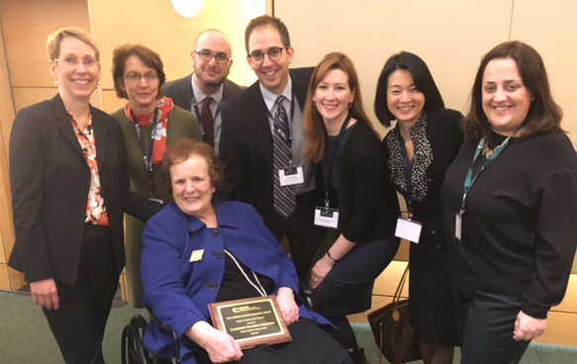Citing her work as a founder of CISSM and of Women in International Security, leading scholars in nuclear policy awarded Senior Fellow Catherine Kelleher the Therese Delpech Memorial Award.
Kelleher was announced as the recipient of this year's award at the 2017 Carnegie Nonproliferation Conference in Washington, D.C., on March 21, 2017.
In accepting the award, Kelleher praised the many contributions of nongovernmental organizations and activities in the nuclear policy space, and urged their continued efforts, particularly as governments around the world lapse into old and tired thinking about ways to reduce nuclear risk.
The Carnegie Endowment for Interantional Peace's Nuclear Policy Program offers the Delpech award every other year to "an individual who has rendered exceptional service to the nongovernmental nuclear policy community." The award also acknowledges "major intellectual contributions to critical debates . . . [and] the time-consuming and often unrecognized work needed to sustain and strengthen our community: mentoring young women and men, constructively critiquing the work of others, creating fora for discussion, and building networks."
In addition to founding CISSM and being an early faculty member at the University of Maryland's School of Public Policy, in 1987, Kelleher and others founded Women in International Security, "as a response to the lack of support for women in the male-dominated foreign policy and defense environment." WIIS has grown into a network of 7,000 experts from across the globe.
Kelleher has written and published widely in both scholarly and popular publications. She has also served as a mentor to countless students in her work at the School of Public Policy and elsewhere. Her government service includes serving as the Personal Representative of the Secretary of Defense in Europe and Deputy Assistant Secretary of Defense for Russia, Ukraine, and Eurasia during the Clinton administration. She also served on the National Security Council staff during the Carter Administration and was a consultant to the Office of the Secretary of Defense, the Arms Control and Disarmament Agency, and the Department of the Army.
Previous winners of the award are Michael Krepon (2015) and Amb. Linton F. Brooks (2013).

